Automatic Roti Puri Maker Motorized Press

Roti is considered to be the most critical and widely consumed item in all Indian cuisines. The process of making roti includes first making wheat dough and then hand pressing as well as manually rolling the dough to achieve desired roti, post which it is flipped onto a pan.
Well we here automate the central part of roti making that is pressing and rolling it to get a flat roti. We here use a press based mechanism to achieve the desired operation. The system makes use of 4 plates with a high torque motor, 3 Support rods, a screw mechanism to develop the machine.
The machine consists of 2 plates in the lowest section which are used to actually press the dough. The motor is mounted on the top most plate. The top plate is secured in place with the help of 3 supporting rods.
When the motor rotates, the screw rotates which inturn moves the nut in horizontal direction. The direction changes with change in screw rotation direction. The nut is mounted to the press plate which presses downwards, when the motor rotates.
When the press reaches its lowest point, the motor stops and starts rotating in opposite direction to pull the press plate upward and allow the user to remove the flattened roti. The mechanism makes use of ball screw based mechanism to pressurize and get flat roti/puri in very less time.

Components
- DC Motor
- Screw and Nut
- Shaft and Joints
- Supporting Rods
- Mounts and Joints
- Press Plates
- Base Frame
- Supporting Frame
- Nuts and Bolts
- Screws and Joints

Block Diagrams

Front View
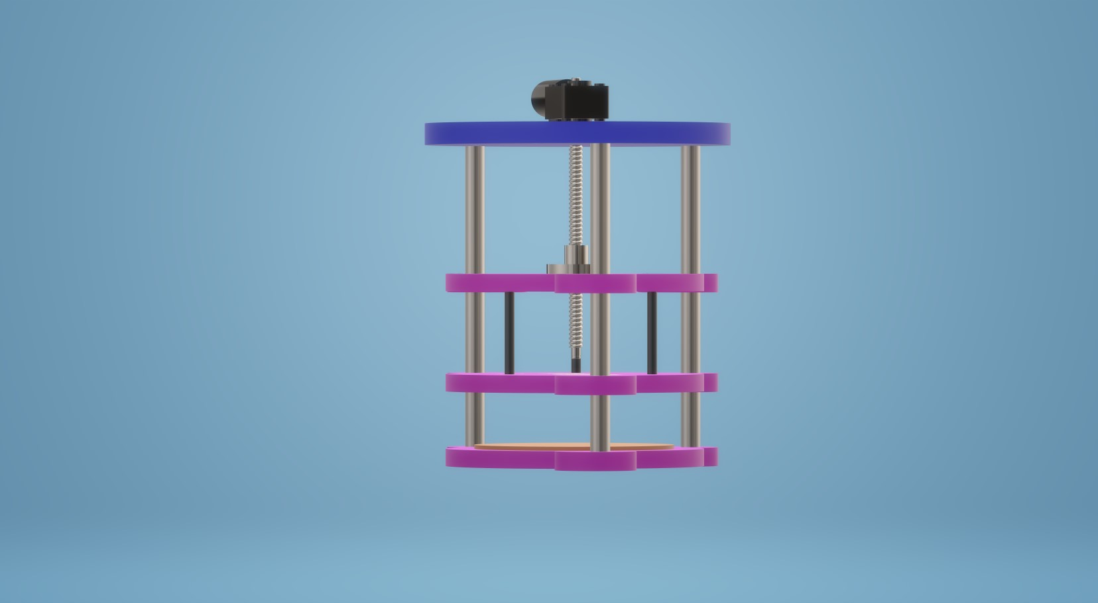

Side View
